**Biological production of ammonia**

Living organisms require the cellular manufacture of amino acids to survive. Intracellularly, fixed nitrogen sources (compounds of nitrogen combined with other elements) are the substrates for amino acid synthesis. While some organisms require uptake of fixed nitrogen from the environment, many species of plants and algal bacteria contain mechanisms for internal manufacture of fixed nitrogen. N2 fixation by nitrogenase enzyme and fixed nitrogen conversion by nitrate/nitrite reductase enzymes are the dominant methods for biologic production of NH+ 4 . The cyanobacteria, Anabaena Variabilis contains both enzymes within its cells. Both processes depend on biochemical pathways for recycling redox cofactors, generation of substrates, and cycling of low potential electron carriers. All of these pathways are present within whole living cells and all are carried out by electron transfer reactions. Figure 1 illustrates the complexities of identifying specific functions, cofactors, substrates, and products of the main reaction centers. The reaction centers of particular interest are nitrate/nitrite reductase and nitrogenase, as they are responsible for production of ammonia. Known reactions pathways are illustrated by solid lines. Possible reactions and pathways are shown in grey. Within living cells there are multiple levels to the function of main reaction centers. Often, they share mediators, cofactors, substrates, and products, creating feedback loops challenging to interrogate. Together, the reaction centers in Figure 1 are the most important to electrochemically induced production of ammonia from whole cell 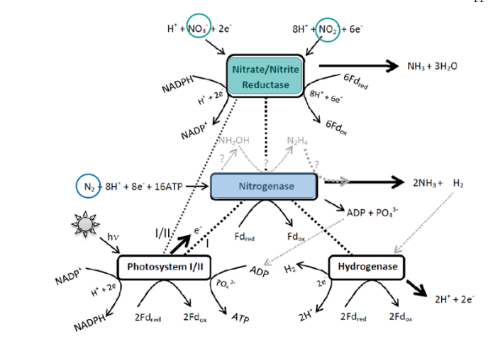

Figure 1: Illustration of the interrelated reaction centers in Anabaena Variabilis. Major reaction centers are shown in boxes and are Nitrate/Nitrite Reductase, Nitrogenase, Hydrogenase, and Photosystems I/II. Peripherally, the reaction centers have shared mediators, cofactors, reactants, and products. Solid lines represent known pathways and reactions. Grey lines and text represent possible reactions and chemicals, not necessarily known paths or species.[1]

Paper: Exploring the mechanism of bioelectrocatalytic production of ammonia with whole cell Anabaena variabilis

Fixed nitrogen is an essential component for growth and development for plants and photosynthetic organisms. Ammonium ion, NH+ 4 is the most easily utilized source of nitrogen and is an essential component in the structure of amino acids (Figure 2).When possible, organisms uptake NH+ 4 directly from the environment, such as the case of ammonium containing fertilizers for crops. When NH+ 4 is not available externally for uptake, cellular processes take over production by enzymes located in the cytosol of the organismís cells. Enzymatic production of NH+4 requires substrate supply. For A. Var., the most common substrates are N2, NO3 , and NO2.

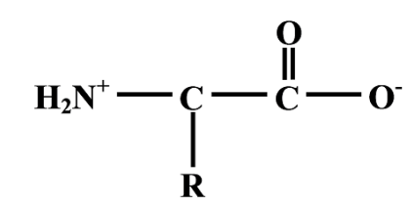

Figure2: The chemical structure of the amino acid backbone. One end is ammonium terminated and the other is carboxylic acid terminated. Cellular synthesis of essential amino acids depends on the availability of ammonium for amino acid synthesis. R changes depending on the noncyclic amino acid. For glutamine, (the ultimate destination for ammonium in Anabaena Variabilis) R = CH2CH2CON

**Mechanisms of assimilation of combined nitrogen in Cyanobacteria**

The incorporation into the cell of nitrogen-containing compounds, which are frequently found at low concentrations (e.g. below 1 µM) in the environment, takes place through permeases that are located in the cytoplasmic membrane.

Multicomponent ABC (ATP-binding cassette)-type uptake transporters have been shown to be involved in the uptake of nitrate and nitrite [2,3] or urea [4] in a number of cyanobacteria. ABC-type permeases are also required for the transport of arginine and glutamine [5]. These permeases use ATP to drive an active, concentrative transport of their substrates. On the other hand, a secondary transporter of the major facilitator superfamily has been identified as the nitrate–nitrite transporter in some marine cyanobacteria [6]. The transport of ammonium is also mediated by secondary permeases, in this case of the Amt family [7,8]. The Amt permeases can be probed with [14C]methylammonium, which has been shown to be concentrated in cells of the unicellular cyanobacterium Synechocystissp. strain PCC 6803 to a level that suggests a membrane potential-driven transport [7].

Intracellular nitrate is sequentially reduced to nitrite and ammonium by nitrate reductase and nitrite reductase, which are the products of the narB and nir genes respectively [9,10]. Cyanobacterial nitrite reductase is homologous with ferredoxin-dependent higher-plant nitrite reductase and contains a [4Fe-4S] cluster and sirohaem as prosthetic groups [10,11]. Electrons from reduced ferredoxin are transferred to the iron–sulphur cluster and then to sirohaem, where nitrite is reduced to ammonium. Cyanobacterial nitrate reductase is homologous with Mo-containing bacterial oxidoreductases but is unique in that it uses ferredoxin as an electron donor, forming tight 1:1 complexes [12]. The Mo cofactor is of the Mo-bis-molybdopterin guanine dinucleotide type [13–15], and the enzyme also contains a [4Fe-4S] cluster [16]. In this enzyme system, electrons flow from reduced ferredoxin to the iron–sulphur cluster and then to the Mo cofactor, where nitrate is reduced to nitrite. The narB and nir genes are clustered together with the nitrate/nitrite permease-encoding genes in numerous cyanobacteria forming an operon with the structure nir-permease genes-narB. The high conservation of this gene arrangement, in which the expression level is higher for the upstream than for the downstream genes in the operon [17], suggests that it ensures the production of a balanced amount of the different proteins of the pathway.

Regarding organic sources of nitrogen used by cyanobacteria, urea is degraded to ammonium and CO2 by a standard bacterial Ni2+-dependent urease [4], whereas arginine is catabolized by an unusual pathway that combines the urea cycle and the arginase pathway rendering ammonium and glutamate as final products [18]. Whatever the nitrogen source used for growth, intracellular ammonium is incorporated into carbon skeletons through the glutamine synthetase–glutamate synthase pathway (reviewed in [1]).

In cyanobacteria, which lack 2-oxoglutarate dehydrogenase, the main metabolic role of 2-oxoglutarate is the incorporation of nitrogen [19]. This metabolic arrangement makes 2-oxoglutarate an indicator of the C to N ratio of the cells [20].

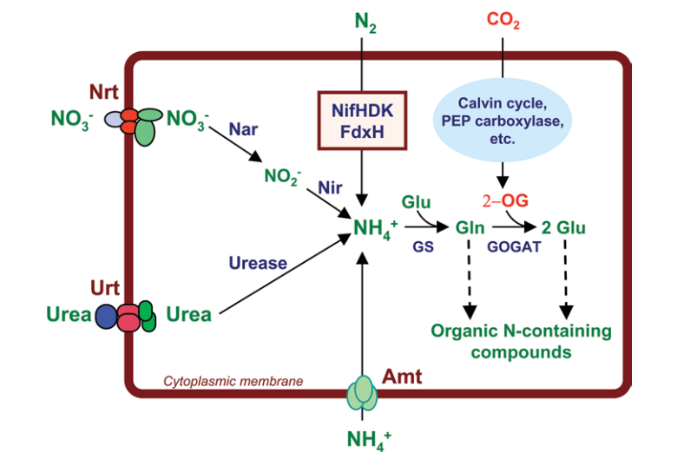

**Figure 3: Main nitrogen assimilation pathways in cyanobacteria**

Combined nitrogen sources are taken up through permeases and metabolized to ammonium, which is incorporated into carbon skeletons through the glutamine synthetase–glutamate synthase pathway. Nitrogen is then distributed from glutamine or glutamate to the other nitrogen-containing organic compounds. Nrt, ABC-type nitrate/nitrite transporter; Urt, ABC-type urea transporter; Amt, ammonium permease; Nar, nitrate reductase; Nir, nitrite reductase; NifHDK, nitrogenase complex; FdxH, heterocyst-specific ferredoxin; PEP carboxylase, phosphoenolpyruvate carboxylase; 2-OG, 2-oxoglutarate; GS, glutamine synthetase; GOGAT, glutamate synthase. The urease reaction releases two molecules of ammonium and one molecule of CO2 per molecule of urea degraded (not indicated). Nitrogenase and FdxH are boxed to note that in some filamentous cyanobacteria N2 fixation takes place in heterocysts

Source paper: **Nitrogen assimilation and nitrogen control in cyanobacteria**

Figure 3 presents a scheme of the main nitrogen assimilation pathways that can be found in cyanobacteria. The scheme highlights the production of intracellular ammonium during the assimilation of different nitrogen sources and the role of 2-oxoglutarate as the C-skeleton for the incorporation of nitrogen into organic material. However, not all these pathways are present at the same time in a cyanobacterial cell, their expression being strictly regulated by the nitrogen source and also by the availability of carbon.

**Photobioreactor cultivation strategies for microalgae and cyanobacteria**

Generally, nitrogen exists in nature in the form of nitrate, nitrite, and dinitrogen. These forms require reduction to ammonium in order to be metabolized for cellular metabolism. This reaction requires energy, which is why most photoautotrophs prefer ammonium as a nitrogen source.161 Ammonium, whether taken up directly from the cultivation medium, or from the metabolism of other nitrogen sources, is incorporated into carbon skeletons via the sequential operations of glutamine synthetase (GS) and glutamate synthase (GOGAT) in the GS-GOGAT pathway.161, 162 Then, nitrogen is distributed from glutamine or glutamate to other nitrogen containing organic compounds.

Why we used genetically modified strains?

Due to the high cost associated with supplying nitrogen to the cultivation medium of photoautotrophs, genetically modified nitrogen-fixing cyanobacteria have gained attention from industrial microbiologists and biotechnologists due to their ability to produce next-generation biofuels and high-value chemicals from carbon dioxide, mineralized water, and sunlight.19, 164-166.

The microbe’s ability to fix atmospheric nitrogen (N2), via specialized cells termed heterocysts, or diazocytes, eliminates the need to add combined nitrogen to the cultivation medium, which would substantially reduce the cost. However, this is not energetically favorable as the process of fixing nitrogen requires 8 electrons and at least 16 molecules of adenosine triphosphate (ATP).167 Also, heterocysts (nitrogen fixing cells) will not form until the cells have been starved of nitrogen for ~20 h.168 The formation of diazocytes typically takes 8-27 h.169 As a consequence, even though these strains can fix atmospheric nitrogen, supplementing the cultivation medium with a source of combined nitrogen may be preferred from an industrial and economic standpoint.

**A little backround**

Since the first isolation of free and symbiotic nitrogen fixing bacteria in 1886, potential applications have been developed in the agriculture field, for instance the use of N2-fixing cyanobacteria as natural nitrogen fertilizers, especially for rice production (Elmerich, 2007; Franche et al., 2009). Some studies have opened other possibilities for diazotrophic cyanobacteria applications (Boussiba, 1988; Brouers & Hall, 1986; Chaurasia & Apte, 2011; Yu et al., 2010). However, despite promising biotechnological applications, few diazotrophic species have been studied to optimize biomass production of cyanobacteria in culture media devoid of combined nitrogen (Fontes et al., 1987; Moreno et al., 2003; Zimmerman, 1987). These studies deal with culture processes including open systems such as raceways and closed systems. These closed systems allow the control of culture conditions (temperature, light, pH, etc.) and the prevention of microbial contamination. This raises the question whether some specific factors could influence the performance of the cultivation in media devoid of combined nitrogen

**Growing Cyanobacteria= Strategy**

Various experimental studies have demonstrated that it is possible to generate noticeable levels of ammonia doing just that. By cultivating specialized strains of cyanobacteria, researchers have continually been able to produce small amounts of ammonia, only needing to supply the microbes with food and air.53,55.

The success has been promising, but it is worth noting that most of these processes have not been scaled up to industrial scales. But, given the small-scale success of this ammonia generation using photobioreactors, it seems like a viable avenue for industrial level ammonia production. Additionally, since photobioreactors generally come in relatively small sizes compared to the average area of industrial production facilities, it would be incredibly easy to make the proposed plant highly modular. Further information about the individual research studies can be found in the appendix, under photobioreactor design below.

2.1.2 Cyanobacteria- Ammonia excretion by mutant strains:

Ammonia produced by Anabaena variabilis (ATCC 29413) is the primary substrate for its enzyme glutamine synthetase; therefore, nearly all ammonium produced enzymatically never exits the cytosol in wild type A. variabilis. The mutant strain SA-1 has had enzymatic reduction of ammonium blocked at the assimilation step of glutamine synthetase and been derepressed to produce the enzymes nitrogenase, nitrate reductase, and nitrite reductase even in the presence of ammonium. The method is fully described by Spiller, et al [7, 15]. The SA-1 genetic mutant strain was provided by K.T. Shanmugam (University of Florida) to Johna Leddy (University of Iowa) who then provided it to the University of Utah.

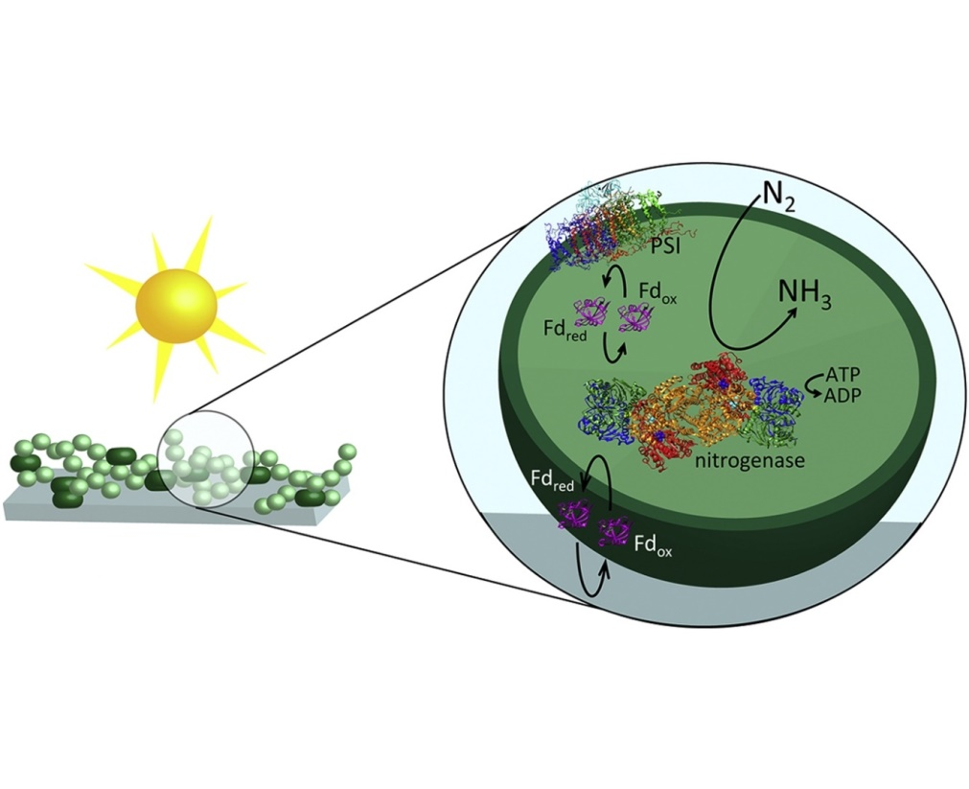

Paper: ***Role of Nitrogenase and Ferredoxin in the Mechanism of Bioelectrocatalytic Nitrogen Fixation by the Cyanobacteria Anabaena variabilis SA-1 Mutant Immobilized on Indium Tin Oxide (ITO) Electrodes***

7, 15= Ammonia-excreting mutant strain of the cyanobacterium Anabaena variabilis supports growth of wheat, [7] C. Latorre, J. Lee, H. Spiller, K. Shanmugam, Ammonium ion-excreting cyanobacterial mutant as a source of nitrogen for growth of rice: a feasibility study

**Background continuation:** It has been reported that certain strains of cyanobacterium, Anabaena variabilis, are capable of excreting the ammonia produced by nitrogenase into the environment (Spiller et al. 1986). When these cultures were grown in association with rice in a greenhouse, ammonia excreted by the mutant strain supported growth of the rice plants (Latorre et al. 1986). ***Ammonia-excreting mutant strain of the cyanobacterium Anabaena variabilis supports growth of wheat.***

The mutant strain SA-1 has been reported to produce ammonia and excrete it into the medium under laboratory conditions (Spiller et al. 1986) and this was the basis of the experiments in which rice growth was enhanced by the organism (Latorre et al. 1986). In their experiments with rice and A. variabilis, Latorre et al. (1986) observed that the growth of rice plants was increased by the addition of strain SA-1 and this increase was suggested to be a consequence of the ammonia produced by the organism. These experiments suggested that supplementation of wheat plants with strain SA-1 should also enhance the growth and nitrogen content of plants. Due to the difficulties of growing wheat plants with the cyanobacteria, where one system requires high moisture and the other requires good aeration in the root zone, a hydroponic system was found to be suitable. However, experiments to determine the levels of nitrogenase activity with and without plants under these specific experimental conditions have yet to be investigated.